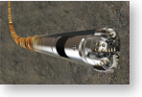

六合伟业DEES云平台仪器维保服务案例
abrasive formation in north america shale
Challenge
Geosteer within a shale wellbore lateral
An operator was drilling a lateral section in a very abrasive formation in a North America
shale play. The abrasiveness caused excessive wear on the drilling equipment and required
a specialized design. To geosteer within the lateral and stay in the target zone, the operator
to maintain and optimize position in the
target zone.
selected the MWD survey and total natural gamma ray (HDS-1L* fixed-collar directional service), coupled with the iPZIG system, based on its unique at-bit sensors that provide real-time bed
Solution
Use iPZIG* at-bit imaging gamma ray and dynamic inclination system with a customized drilling assembly to quickly interpret formation bed boundaries and PayZone Steering* real-time forward modeling to accurately geosteer the
horizontal section.
ReSultS
Successfully geosteered the horizontal section, staying in the target zone 100% of the time.
boundary measurements.
The iPZIG system positions the image natural gamma ray and dynamic inclination measurements close to the bit to reduce the reaction time for making critical geosteering decisions and
maintaining the wellbore in the targeted zone. Measurements of the bed boundary were
characterized within the target interval, allowing for new calculation of apparent and true bed dip and direction. The iPZIG system’s close proximity to the bit enabled quick geosteering
decisions to adjust the well trajectory and reduce risks while navigating through critical hole sections and maintaining the wellbore in the target zone.



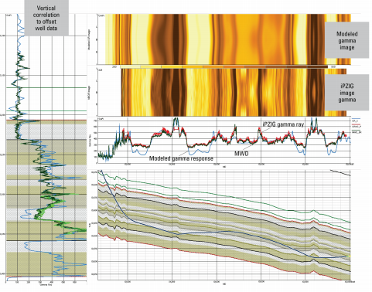
Steering interpretation based on iPZIG measurements correlated to PayZone Steering geologic model based
on offset data.

drilling

CaSe Study: PathFinder technologies provide advanced measuring and imaging capabilities for accurate well positioning in North America shale play

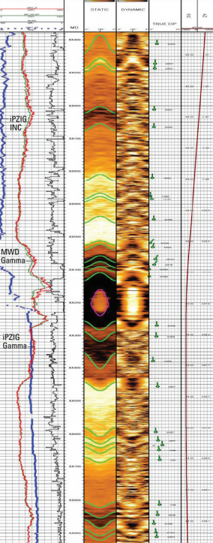

Real-time static and dynamic normalization iPZIG image log with dip calculations.

*Mark of Schlumberger.
Copyright © 2012 Schlumberger. All rights reserved. 12-PF-0022

advanced measuring, imaging, and modeling
When the borehole intersects a geologic feature, it appears as a sinusoid on
the borehole natural gamma ray image. By fitting the sinusoid to the image data, apparent and true dip angle and dip direction can be quantitatively determined. Post processing of the image natural gamma ray using PayZone Steering forward modeling generates an earth model based on offset data. The iPZIG dynamic
inclination and image gamma ray 8–16 sector data provides the drilling and
geological teams with accurate real-time at-bit information. This allows for quick directional and geological interpretation of the wellbore to maintain the correct position within the defined target interval.
accurate geosteering
The iPZIG at‐bit measurements allowed for greater directional control and
confidence in time‐critical decision making relative to the wellbore trajectory to
maximize in‐zone exposure. Geological features observed from the iPZIG 8-sector real-time images aided in the geosteering interpretations. This in-depth information gained from the combined technologies helped the operator correctly determine the position and accurately direct the drilling, staying within the target interval.

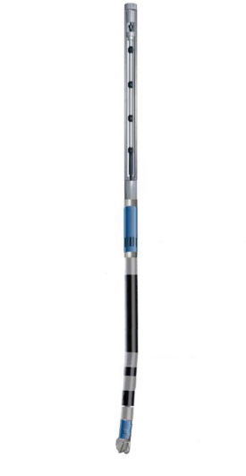  HDS-1L service 29.9 ft  iPZIG UXM  (upper sub)  5.9  ft  1.8 ft  29.8 ft  iPZIG LXM 3.6 ft (lower sub) 1.0 ft  MLWD sensor offsets from bit to measurement point (MP). | Directional MP, 54.8 ft  Gamma MP, 46.7 ft  Float sub  Steerable motor  Near-bit inclination MP, 3.3  Near-bit gamma MP, 2.7 ft  Bit  www.slb.com/iPZig    A schlumberger company

